**Ulric Aird**

**Wireless Assessment**

For this assessment, I went a deep dive into how wireless communication works. I used Cisco Packet Tracer to simulate and understand how wireless communication works and how each device communicates with each other.

First off, I added the various devices from the instructions that were provided for on Moodle, and I placed it into my workspace. I then proceeded to turn off each device and change each port from the ethernet port to a wireless adaptor port and proceeded to turn the devices back on again. I then configured each device with the various IP Address, Subnet Mask and Default Gateway that was listed on the instructions. I then renamed the SSID to “UlricWifi” and set the authentication to “WPA2-PSK” with the passphrase being “ulricismswilliamsfavoritestudent”. After all this was done, I then proceeded to send PDU Test to each device to another device. While testing this, I found out that you can’t send a test from a device to the wireless router, but you can send a test from the router to the any device, which is sort of confusing. I then proceeded to open the terminal in each device and ping each of them and as expected, the router wasn’t responding to any of the ping requests, but all the other devices were.

This overall lab was a great experience, and I learned many things about how wireless networks work. I will take the knowledge what I learned and the experience and I will apply it in the real world.

Configuration Table

|  |  |  |  |
| --- | --- | --- | --- |
| Device | IP Address | Subnet Mask | Default Gateway |
| Wireless Router | 192.168.1.1 | 255.255.255.0 | 192.168.1.1 |
| Laptop 1 | 192.168.1.3 | 255.255.255.0 | 192.168.1.1 |
| Laptop 2 | 192.168.1.4 | 255.255.255.0 | 192.168.1.1 |
| Smartphone | 192.168.1.5 | 255.255.255.0 | 192.168.1.1 |
| Printer | 192.168.1.6 | 255.255.255.0 | 192.168.1.1 |
| Server | 192.168.1.7 | 255.255.255.0 | 192.168.1.1 |
| Server 2 | 192.168.1.9 | 255.255.255.0 | 192.168.1.1 |

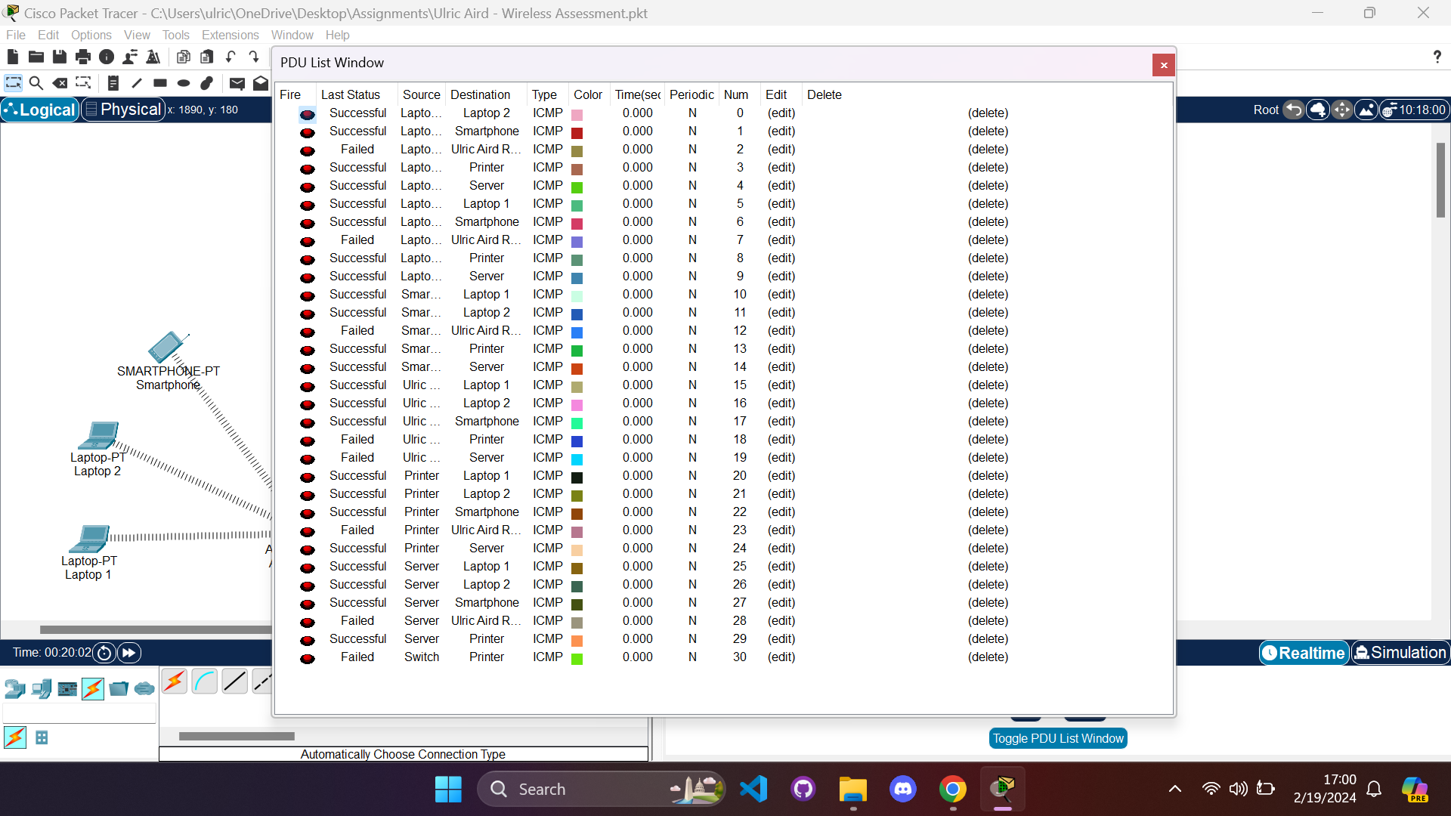PDU Test List

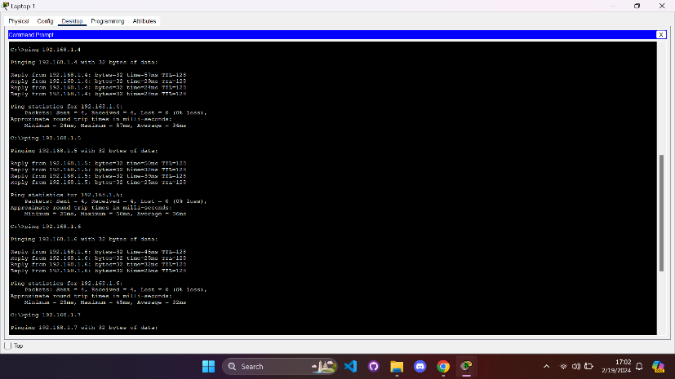Laptop 1 Ping Test

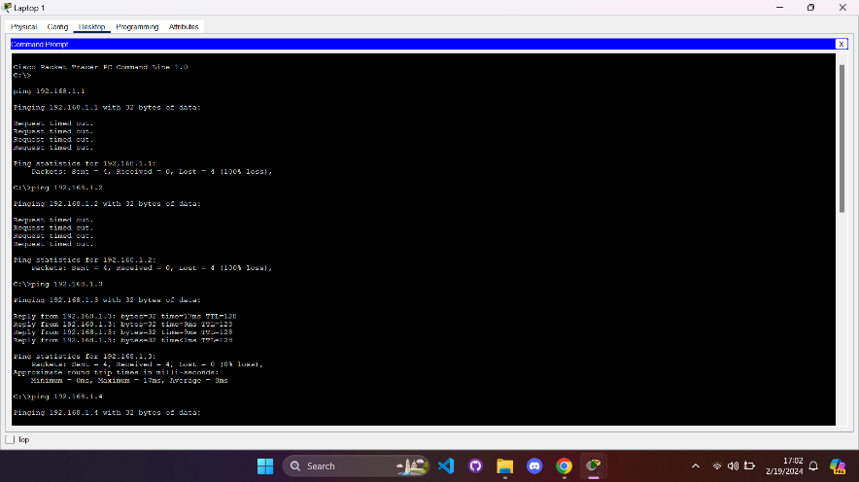

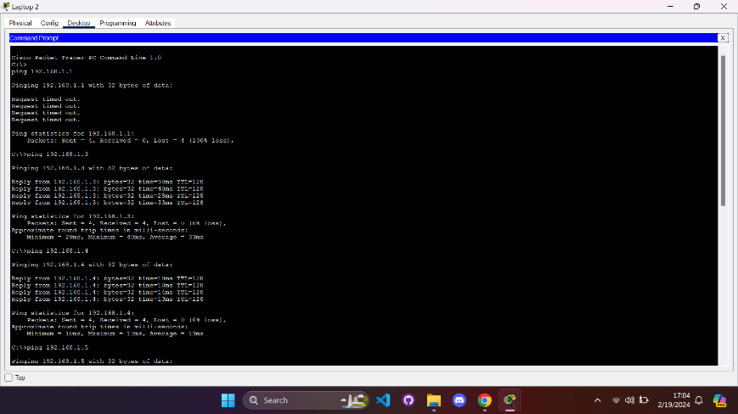Laptop 2 Ping Test

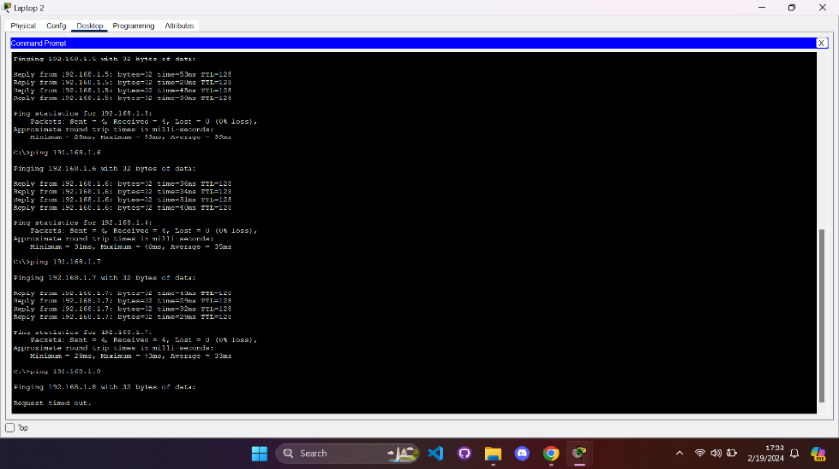

Smartphone Ping Test

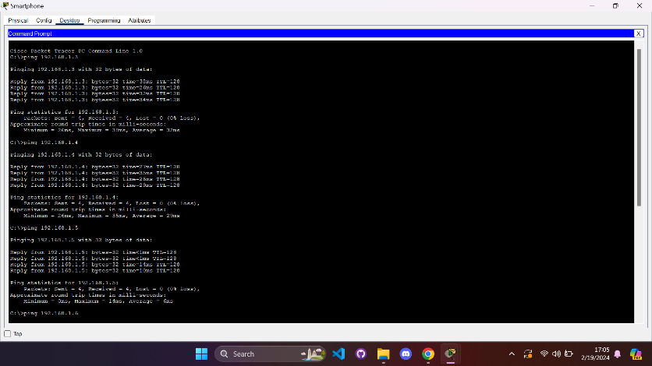

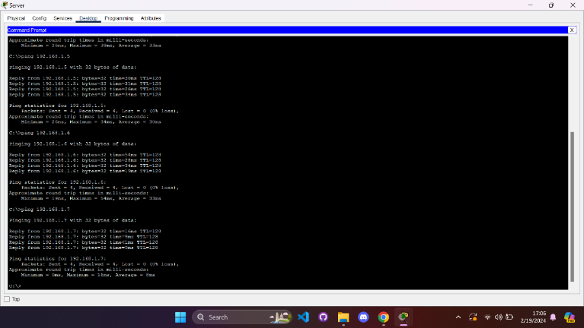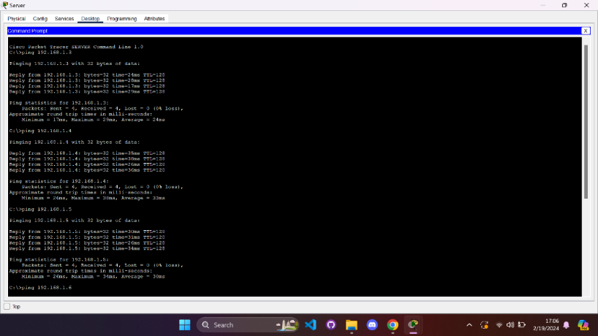Server Ping Test